Auto Scaling Groups(ASG)
Task 1: Create a VPC in N. Virginia
Planned resource values
Use these names throughout the project:
Resource | Value
Region | US East — N. Virginia
Region code | us-east-1
VPC name | ASG-Lab-VPC
VPC CIDR | 10.0.0.0/16
Tenancy | Default
IPv6 | No IPv6 CIDR block
A VPC is an isolated virtual network in AWS. After creating it, we can add subnets, route tables, gateways and EC2 resources.
Step 1: Select the region
- Sign in to the AWS Management Console.
- Look at the top-right corner.
- Click the current region.
- Select:
US East (N. Virginia) us-east-1
Make sure you remain in us-east-1 for all tasks in this project.
Step 2: Open the VPC console
- In the AWS search bar, enter:
VPC
- Select VPC.
- In the left navigation menu, select Your VPCs.
- Click Create VPC.
Step 3: Select the VPC creation option
Under Resources to create, select:
VPC only
Do not select VPC and more because we will create every component manually for practice.
Step 4: Enter the VPC details
Configure the following:
Name tag
ASG-Lab-VPC
IPv4 CIDR manual input
10.0.0.0/16
A /16 VPC gives us enough address space to create multiple /24 public and private subnets. AWS allows IPv4 VPC CIDR sizes between /16 and /28.
IPv6 CIDR block
Select:
No IPv6 CIDR block
Tenancy
Select:
Default
Tags
AWS normally creates the Name tag automatically from the value entered above:
Key | Value
Name | ASG-Lab-VPC
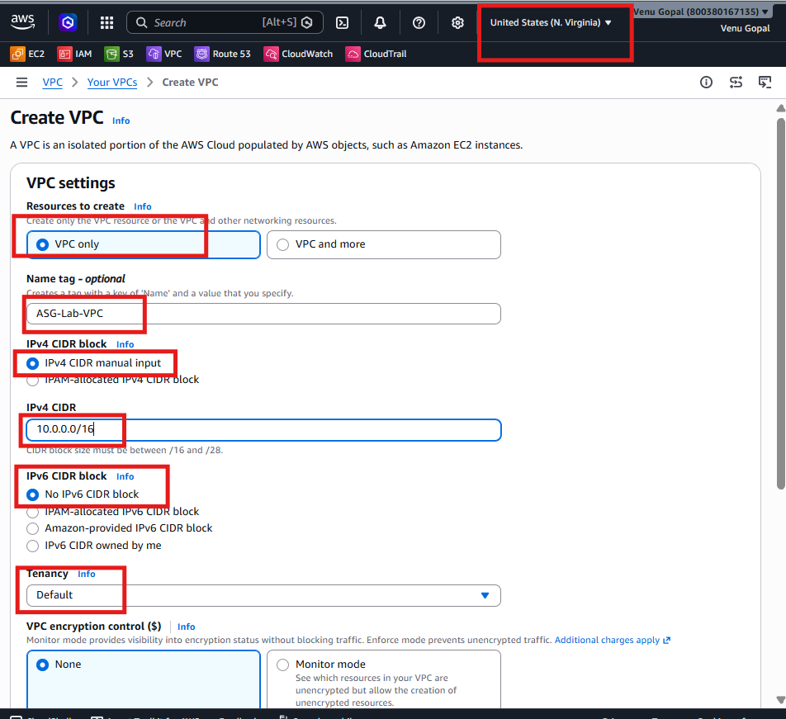
Step 5: Create the VPC
Click:
Create VPC
You should receive:
Successfully created vpc-xxxxxxxxxxxxxxxxx / ASG-Lab-VPC
Click View VPC.
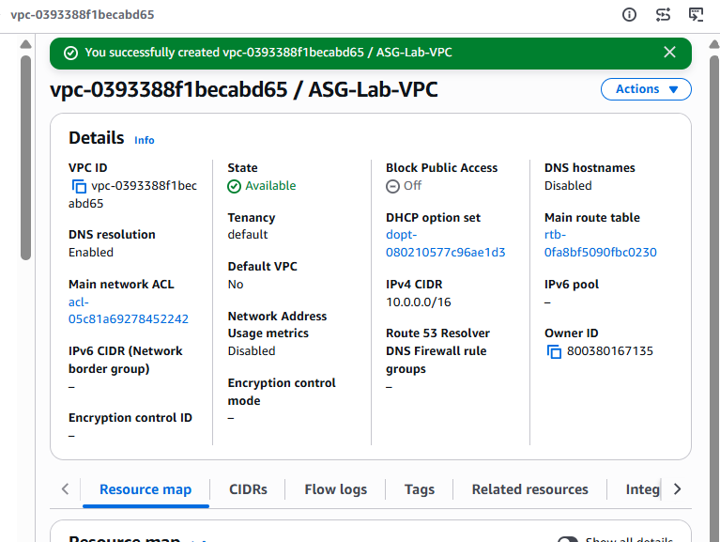
Step 6: Enable DNS settings
- Select ASG-Lab-VPC.
- Click Actions.
- Select Edit VPC settings.
- Under DNS settings, enable:
Enable DNS resolution
Enable DNS hostnames
- Click Save changes.
DNS hostnames allow EC2 instances with public addresses to receive public DNS names, while DNS resolution allows resources to resolve domain names.
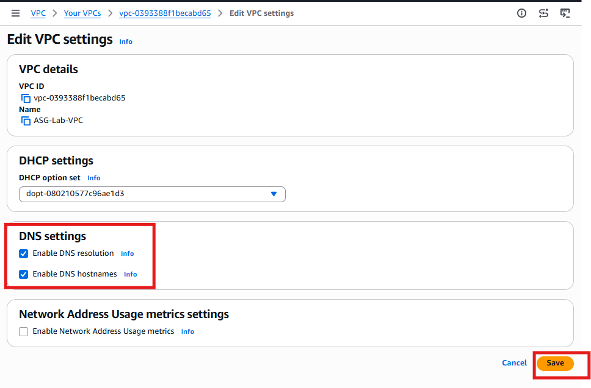

Task 2: Create Public and Private Subnets
Since we'll be creating an Application Load Balancer and Auto Scaling Group, we'll create 4 subnets (2 public + 2 private).
Final Subnet Design
Subnet Name | CIDR | Availability Zone | Purpose
Public-Subnet-1 | 10.0.1.0/24 | us-east-1a | ALB + NAT Gateway + Bastion
Public-Subnet-2 | 10.0.2.0/24 | us-east-1b | ALB
Private-Subnet-1 | 10.0.11.0/24 | us-east-1a | EC2 / Auto Scaling
Private-Subnet-2 | 10.0.12.0/24 | us-east-1b | EC2 / Auto Scaling

Step 1: Open Subnets
Go to
VPC
↓
Subnets
Click
Create subnet

Step 2: Select VPC
Choose
ASG-Lab-VPC

Step 3: Create Public Subnet-1
VPC ID
ASG-Lab-VPC
Name
Public-Subnet-1
Availability Zone
us-east-1a
IPv4 CIDR
10.0.1.0/24
Click
Create Subnet
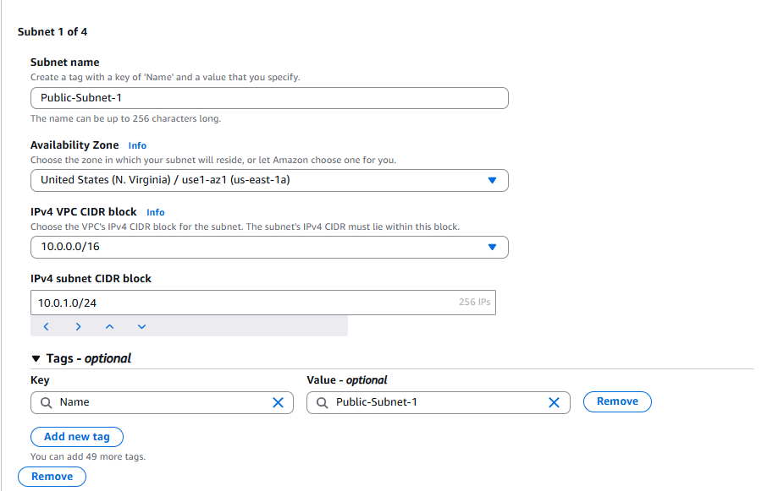

Step 4: Create Public Subnet-2
Again click
Create Subnet
Fill:
Field | Value
Name | Public-Subnet-2
AZ | us-east-1b
CIDR | 10.0.2.0/24
Click
Create Subnet
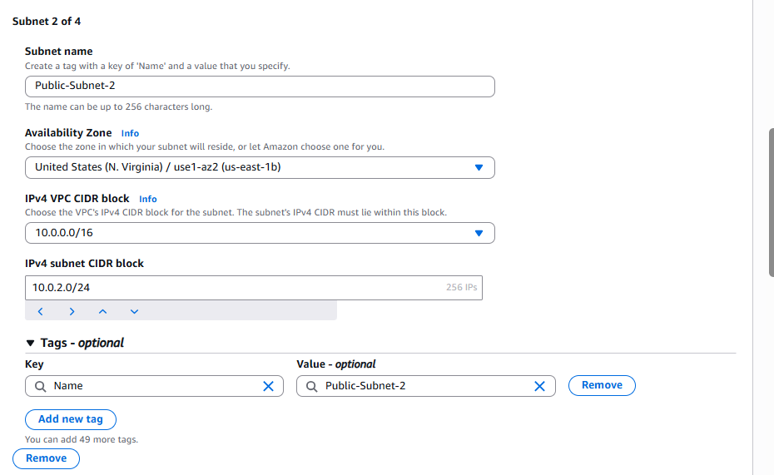

Step 5: Create Private Subnet-1
Click
Create Subnet
Fill:
Field | Value
Name | Private-Subnet-1
AZ | us-east-1a
CIDR | 10.0.11.0/24
Click
Create Subnet
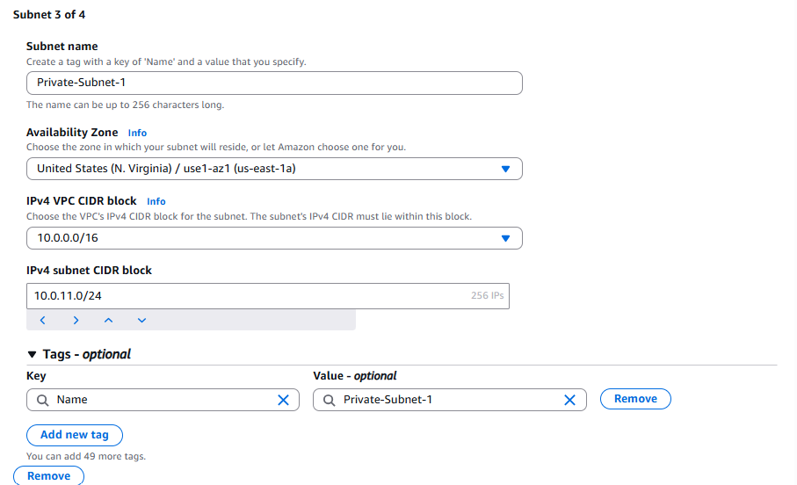

Step 6: Create Private Subnet-2
Click
Create Subnet
Fill:
Field | Value
Name | Private-Subnet-2
AZ | us-east-1b
CIDR | 10.0.12.0/24
Click
Create Subnet

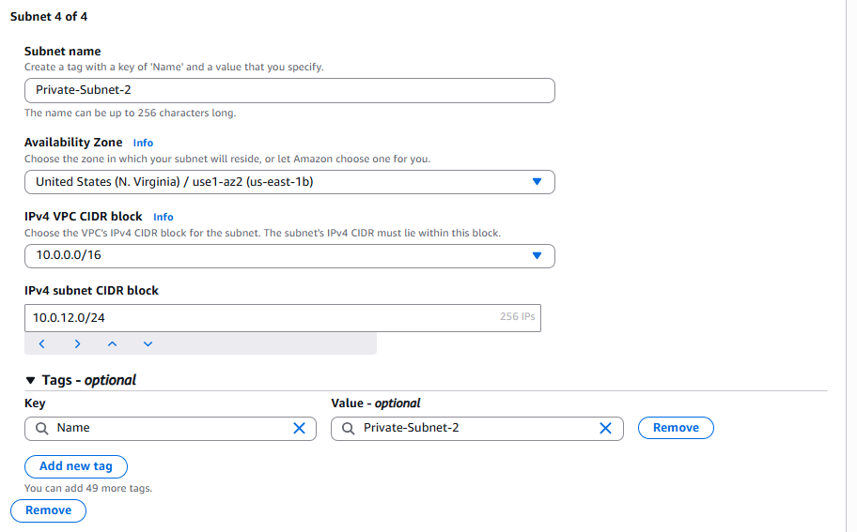

Step 7: Enable Auto-Assign Public IP
Only for the public subnets.
Select
Public-Subnet-1
Click
Actions
↓
Edit subnet settings
Enable
Auto-assign public IPv4 address
Save.
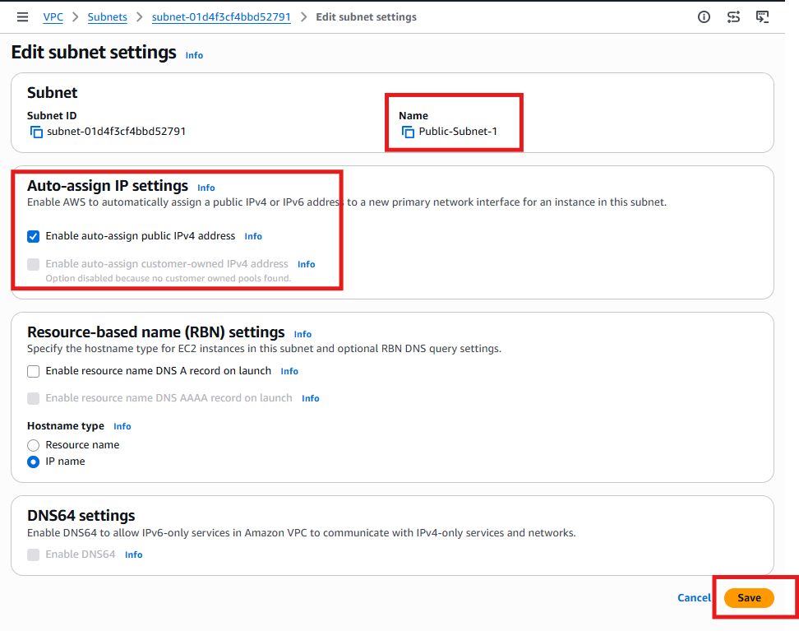

Repeat the same for
Public-Subnet-2
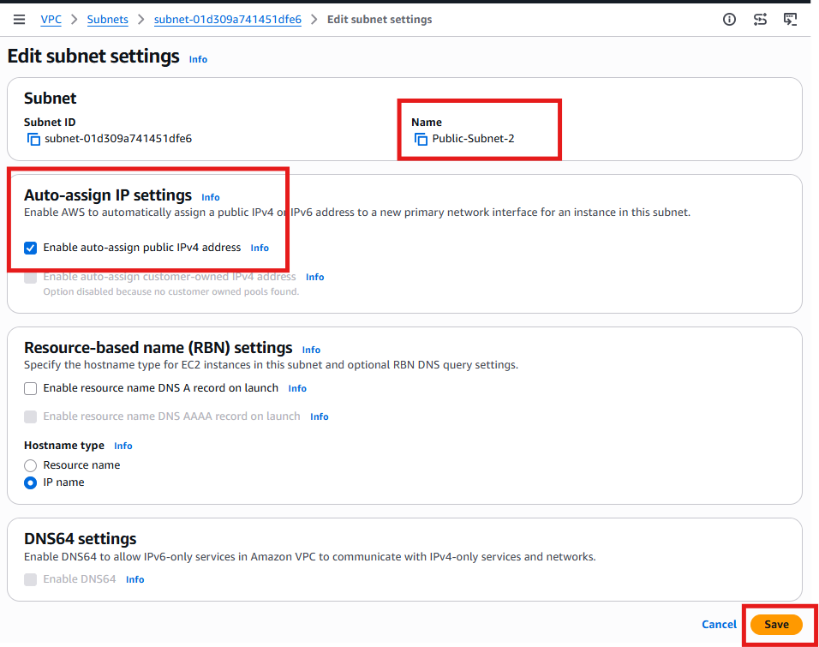

Task 3: Create and Attach an Internet Gateway
The Internet Gateway allows resources in the public subnets to communicate with the internet.
Step 1: Open Internet Gateways
Go to:
VPC Console
→ Internet gateways
Click:
Create internet gateway
Step 2: Enter the Internet Gateway name
For Name tag, enter:
ASG-Lab-IGW
Click:
Create internet gateway
You should see the state as:
Detached
That is normal until we attach it to the VPC.
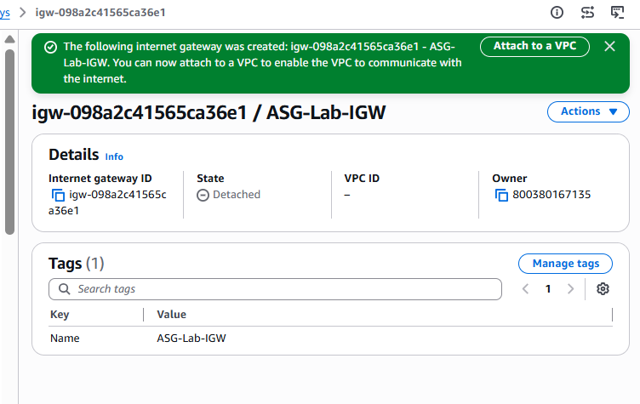
Step 3: Attach the IGW to the VPC
Select:
ASG-Lab-IGW
Click:
Actions
→ Attach to a VPC
Choose:
ASG-Lab-VPC
Click:
Attach internet gateway
Step 4: Verify
Confirm these values:
Property | Expected value
Name | ASG-Lab-IGW
State | Attached
VPC | ASG-Lab-VPC
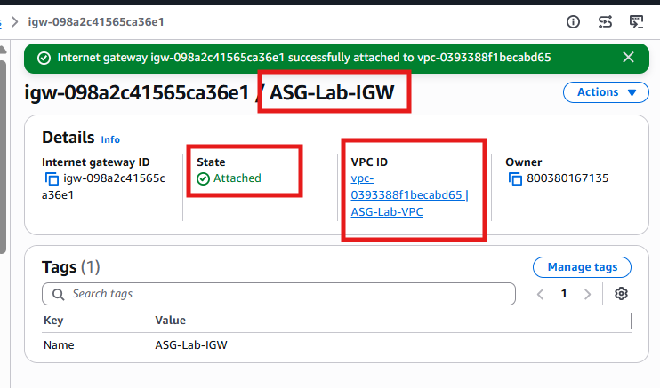
Architecture after Task 3
Internet
|
ASG-Lab-IGW
|
ASG-Lab-VPC
|
├── Public-Subnet-1
├── Public-Subnet-2
├── Private-Subnet-1
└── Private-Subnet-2
The IGW is attached to the VPC, not directly to a subnet. In the next task, the public route table will send internet traffic through this IGW.
Task 3 result
Internet Gateway: ASG-Lab-IGW
Attached VPC: ASG-Lab-VPC
State: Attached

Task 4: Create Route Tables
We need two route tables:
- Public Route Table → Internet access through the Internet Gateway (IGW)
- Private Route Table → Internet access through the NAT Gateway (we'll add the NAT route in Task 5)

Step 1: Open Route Tables
Go to:
VPC
↓
Route Tables
Click:
Create route table

Step 2: Create the Public Route Table
Enter the following:
Field | Value
Name | ASG-Public-RT
VPC | ASG-Lab-VPC
Click:
Create Route Table
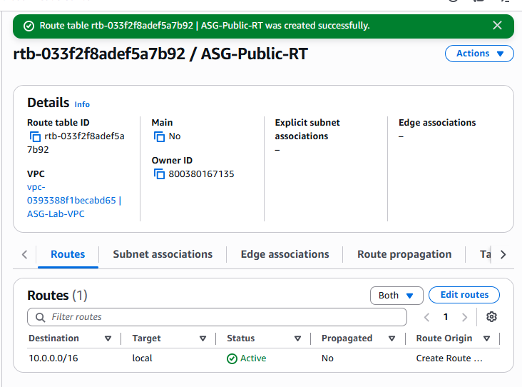

Step 3: Create the Private Route Table
Again click:
Create Route Table
Enter:
Field | Value
Name | ASG-Private-RT
VPC | ASG-Lab-VPC
Click:
Create Route Table
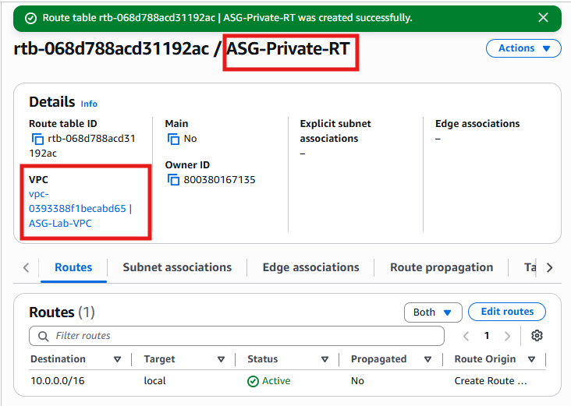

Step 4: Add Internet Route to the Public Route Table
Select:
ASG-Public-RT
Go to
Routes
↓
Click
Edit routes
↓
Click
Add route
Fill:
Destination | Target
0.0.0.0/0 | Internet Gateway
Target | ASG-Lab-IGW
It should look like:
Destination | Target
10.0.0.0/16 | local
0.0.0.0/0 | igw-xxxxxxxx
Click:
Save changes
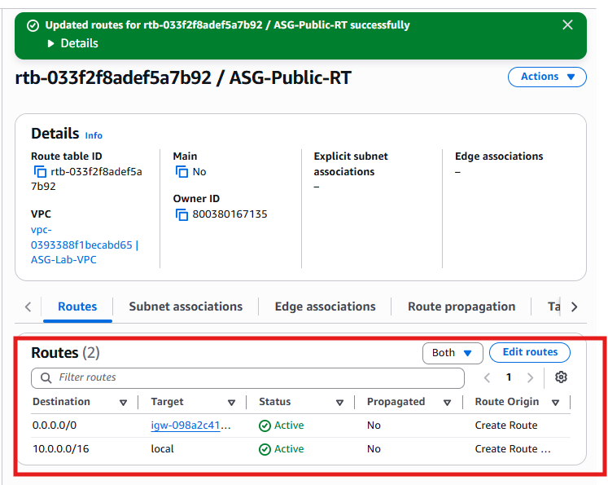

Step 5: Associate Public Subnets
Go to
Subnet Associations
↓
Click
Edit subnet associations
Select:
✅ Public-Subnet-1
✅ Public-Subnet-2
Click
Save associations
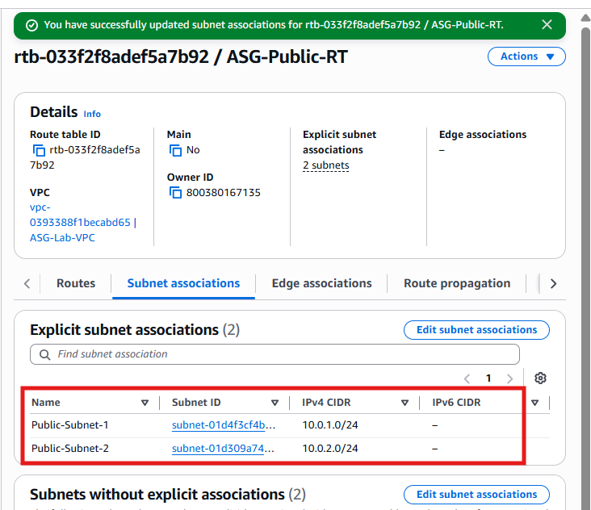

Step 6: Associate Private Subnets
Select:
ASG-Private-RT
Go to
Subnet Associations
↓
Click
Edit subnet associations
Select:
✅ Private-Subnet-1
✅ Private-Subnet-2
Click
Save associations
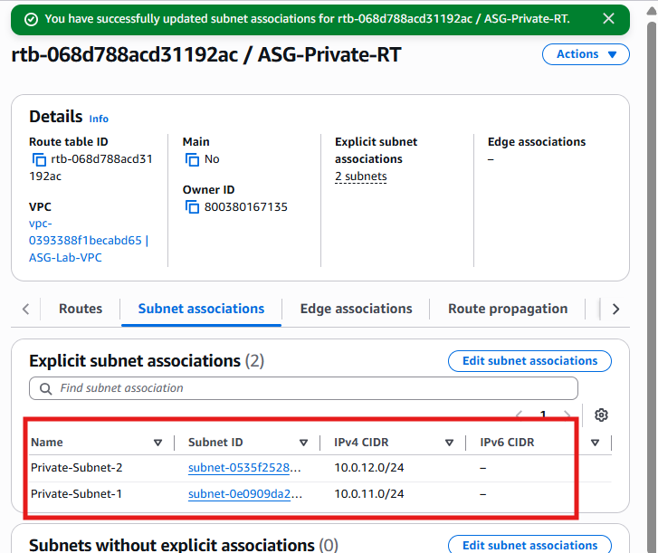

Step 7: Verify Route Tables
ASG-Public-RT
Routes
Destination | Target
10.0.0.0/16 | local
0.0.0.0/0 | ASG-Lab-IGW
Associated Subnets
- Public-Subnet-1
- Public-Subnet-2
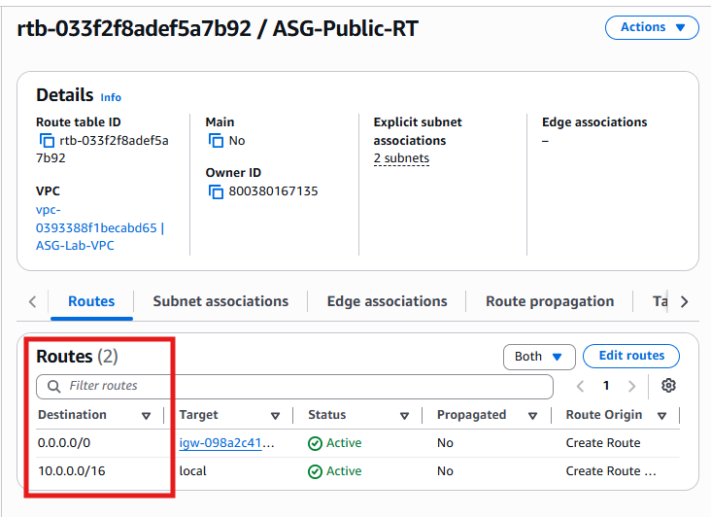

ASG-Private-RT
Routes
Destination | Target
10.0.0.0/16 | local
Note: Do not add 0.0.0.0/0 yet. We'll add that after creating the NAT Gateway in Task 5.
Associated Subnets
- Private-Subnet-1
- Private-Subnet-2
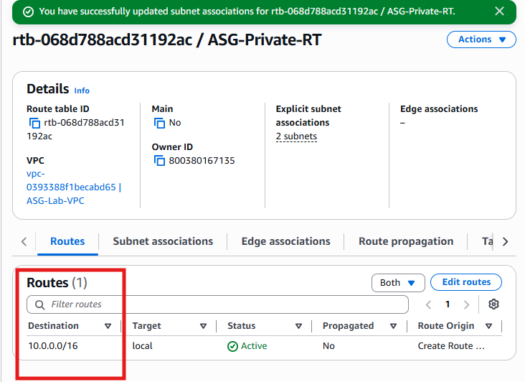

Architecture After Task 4
Internet
│
ASG-Lab-IGW
│
┌─────────────┴─────────────┐
│ │
ASG-Public-RT ASG-Private-RT
│ │
┌──────┴──────┐ ┌──────┴──────┐
│ │ │ │
Public-1 Public-2 Private-1 Private-2

Task 5: Create NAT Gateway and Update Private Route Table
The NAT Gateway allows EC2 instances in the private subnets to access the internet for updates and package installation, without accepting direct inbound internet traffic.
Step 1: Open NAT Gateways
Go to:
VPC
→ NAT gateways
Click:
Create NAT gateway
Step 2: Configure NAT Gateway
Enter these values:
Field | Value
Name | ASG-Lab-NAT
Subnet | Public-Subnet-1
Connectivity type | Public
Elastic IP allocation ID | Allocate Elastic IP
Click:
Allocate Elastic IP
Then click:
Create NAT gateway
Step 3: Wait for NAT Gateway
The NAT Gateway state will first show:
Pending
Wait until it becomes:
Available
Do not update the route table while the NAT Gateway is still pending.
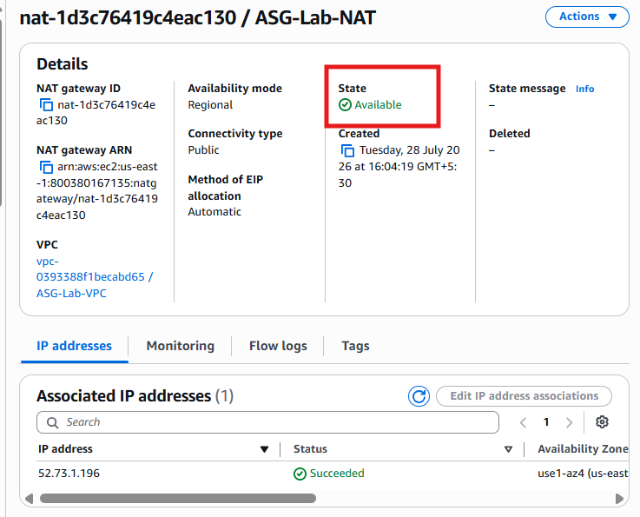
Step 4: Update the Private Route Table
Go to:
VPC
→ Route tables
Select:
ASG-Private-RT
Open the Routes tab and click:
Edit routes
Click:
Add route
Enter:
Destination | Target
0.0.0.0/0 | NAT Gateway
Target resource | ASG-Lab-NAT
Click:
Save changes
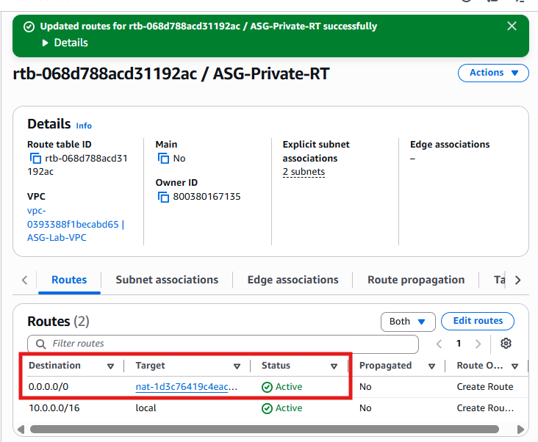
Step 5: Verify the Private Route Table
The routes should now be:
Destination | Target
10.0.0.0/16 | local
0.0.0.0/0 | ASG-Lab-NAT
The associated subnets should be:
- Private-Subnet-1
- Private-Subnet-2
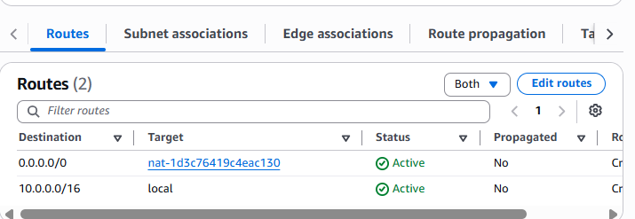
Important clarification
The NAT Gateway is deployed in the public subnet, but it is not directly “attached” to the private subnet.
The private subnets use it through this route:
Private subnet
↓
ASG-Private-RT
↓
0.0.0.0/0 → NAT Gateway
↓
Public subnet
↓
Internet Gateway
↓
Internet
Architecture after Task 5
Internet
|
ASG-Lab-IGW
|
Public-Subnet-1
|
ASG-Lab-NAT
|
ASG-Private-RT
/ \
Private-Subnet-1 Private-Subnet-2

Task 6: Create Two EC2 Instances
We will create:
Instance Name | Subnet | Purpose
Public-EC2 | Public-Subnet-1 | Bastion/Admin Server
Private-EC2 | Private-Subnet-1 | Apache Web Server

Step 1: Open EC2
Go to:
EC2
→ Instances
Click:
Launch Instance

Step 2: Configure Public EC2
Name
Public-EC2

Amazon Machine Image (AMI)
Choose:
Amazon Linux 2023

Instance Type
t2.micro
(Free Tier eligible in many accounts.)

Key Pair
Choose your existing key pair, for example:
venu-key
(or create a new one if needed.)

Network Settings
Click Edit.
Configure:
Setting | Value
VPC | ASG-Lab-VPC
Subnet | Public-Subnet-1
Auto-assign Public IP | Enable

Security Group
Create a new security group.
Name
Public-EC2-SG
Inbound Rules
Type | Port | Source
SSH | 22 | My IP
HTTP | 80 | Anywhere (0.0.0.0/0)
Leave outbound as All traffic.

Launch
Click:
Launch Instance

Step 3: Create the Private EC2
Click:
Launch Instance
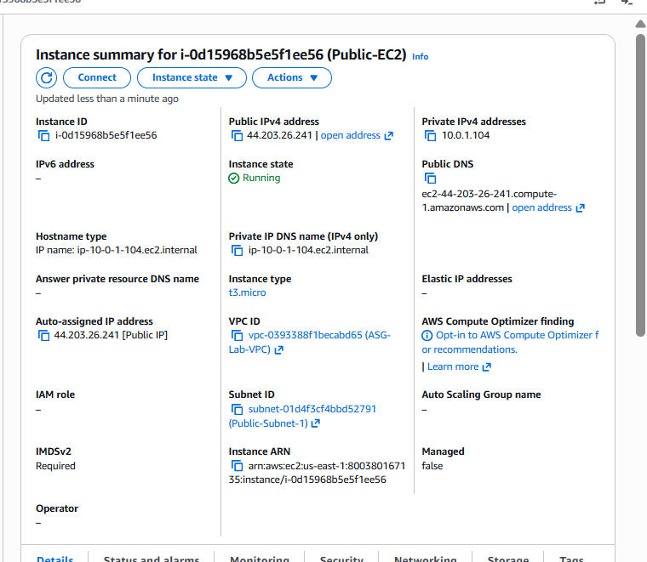

Name
Private-EC2

AMI
Amazon Linux 2023

Instance Type
t2.micro

Key Pair
Select the same key pair.

Network
Setting | Value
VPC | ASG-Lab-VPC
Subnet | Private-Subnet-1
Auto-assign Public IP | Disable

Security Group
Create another security group.
Name
Private-EC2-SG
Inbound Rules
Type | Port | Source
SSH | 22 | Public-EC2-SG
HTTP | 80 | ASG-Lab-VPC CIDR (10.0.0.0/16)
The SSH rule allows you to connect from the public EC2 (bastion host) to the private EC2. The HTTP rule allows traffic from within the VPC, which will include the load balancer in a later step if needed.
Outbound:
All Traffic
Launch the instance.
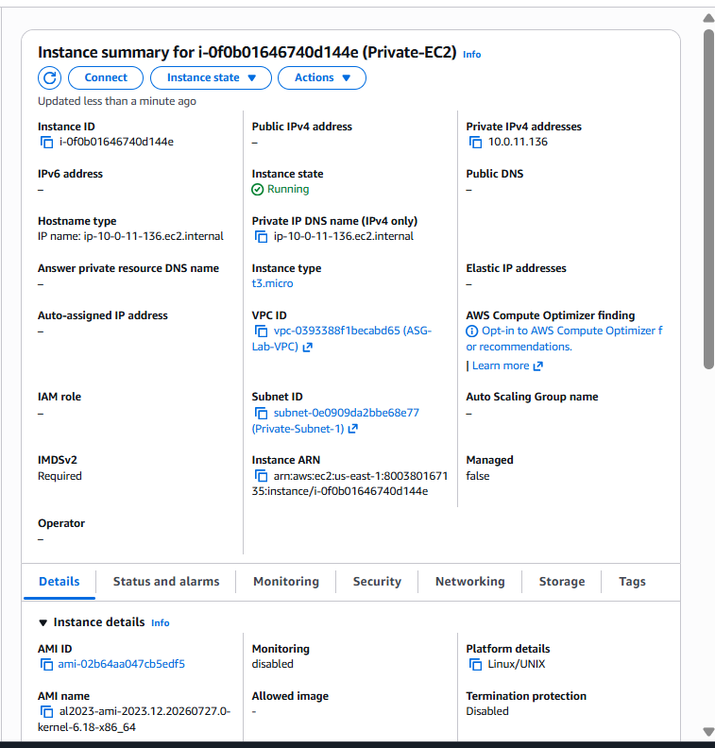

Step 4: Verify
You should now see:
Instance | Public IP | Private IP
Public-EC2 | Yes | 10.0.1.x
Private-EC2 | No | 10.0.11.x

Step 5: Test Connectivity
- SSH to Public-EC2 from your local machine.
- From Public-EC2, SSH to Private-EC2 using its private IP.
Example:
ssh -i your-key.pem ec2-user@<Public-EC2-Public-IP>
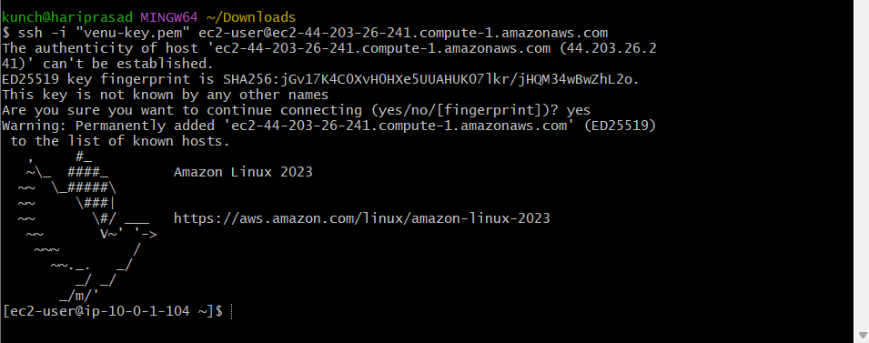
Then:
ssh -i your-key.pem ec2-user@10.0.11.x
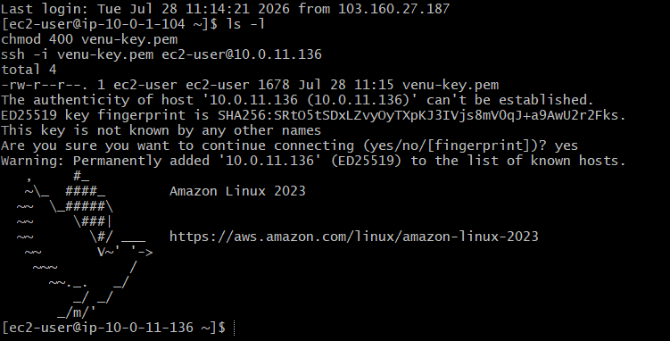
If the second connection works, your networking (VPC, route tables, NAT, and security groups) is configured correctly.

Architecture After Task 6
Internet
|
Internet Gateway
|
Public-Subnet-1
|
Public-EC2 (Bastion)
|
Private IP
|
Private-Subnet-1
|
Private-EC2

Task 7: Install Apache on Both EC2 Instances
We'll perform these steps on both:
- ✅ Public-EC2
- ✅ Private-EC2

Step 1: Install Apache (httpd)
Run the following commands on Public-EC2 first:
sudo dnf update -y
sudo dnf install httpd -y
Verify installation:
httpd -v
Expected output:
Server version: Apache/2.4.x
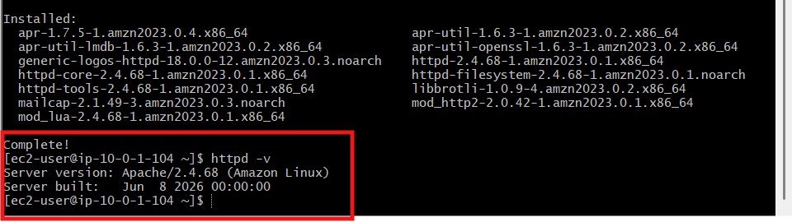

Step 2: Start Apache
sudo systemctl start httpd
Enable it to start automatically after reboot:
sudo systemctl enable httpd
Check the service status:
sudo systemctl status httpd
Expected:
Active: active (running)
Press:
q
to exit the status screen.
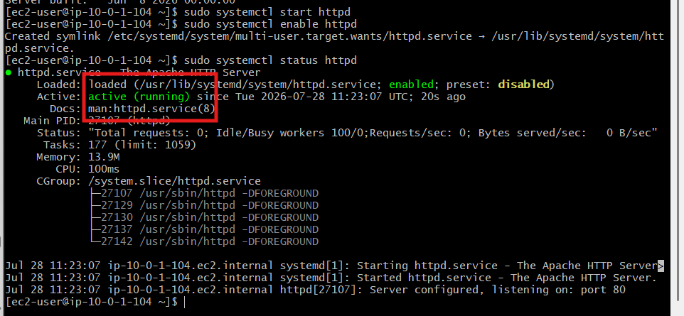

Step 3: Create a Sample Web Page
Replace the default page with a custom one.
sudo tee /var/www/html/index.html > /dev/null <<EOF
<!DOCTYPE html>
<html>
<head>
<title>Apache Server</title>
</head>
<body style="text-align:center;font-family:Arial;margin-top:80px;">
<h1>Welcome to Apache Web Server</h1>
<h2>Public EC2 Instance</h2>
<p>Hostname: $(hostname)</p>
<p>Private IP: $(hostname -I)</p>
</body>
</html>
EOF
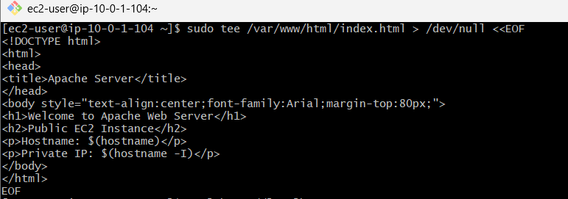

Step 4: Test Apache
From the Public-EC2 instance itself:
curl http://localhost
You should see the HTML you just created.
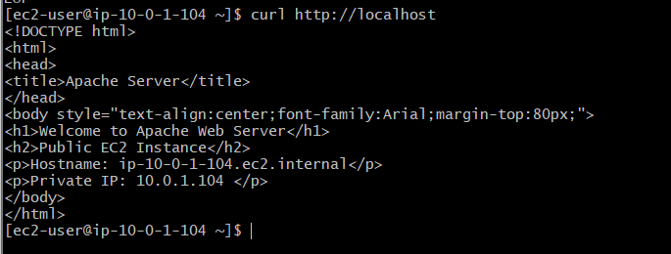

Step 5: Repeat on Private-EC2
SSH into the Private-EC2:
ssh -i venu-key.pem ec2-user@10.0.11.136
Run:
sudo dnf update -y
sudo dnf install httpd -y
sudo systemctl start httpd
sudo systemctl enable httpd
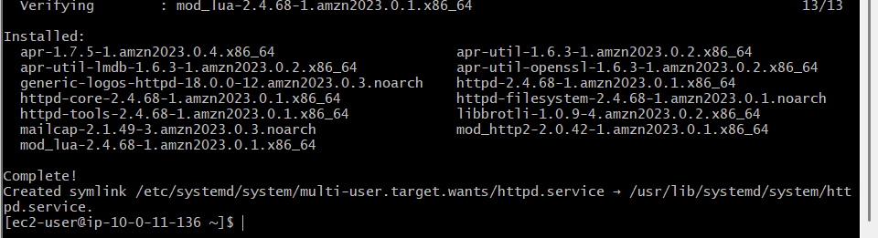
Create a different page:
sudo tee /var/www/html/index.html > /dev/null <<EOF
<!DOCTYPE html>
<html>
<head>
<title>Apache Server</title>
</head>
<body style="text-align:center;font-family:Arial;margin-top:80px;">
<h1>Welcome to Apache Web Server</h1>
<h2>Private EC2 Instance</h2>
<p>Hostname: $(hostname)</p>
<p>Private IP: $(hostname -I)</p>
</body>
</html>
EOF
Test it:
curl http://localhost
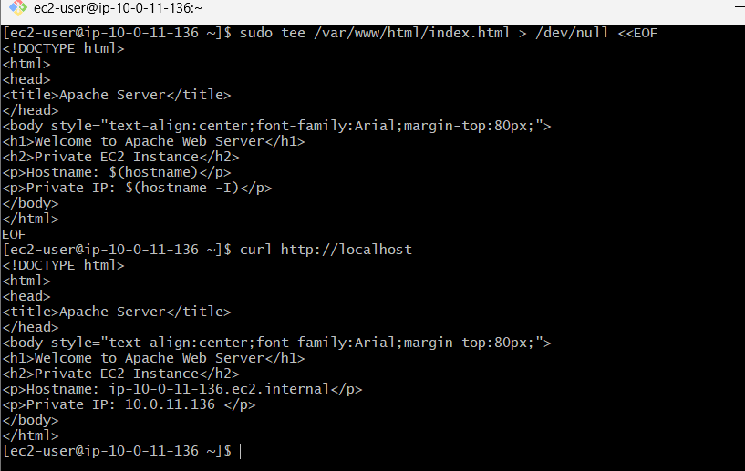

Step 6: Verify Network Connectivity
Public EC2
From your laptop, open:
http://<Public-EC2-Public-IP>
You should see:
Welcome to Apache Web Server
Public EC2 Instance
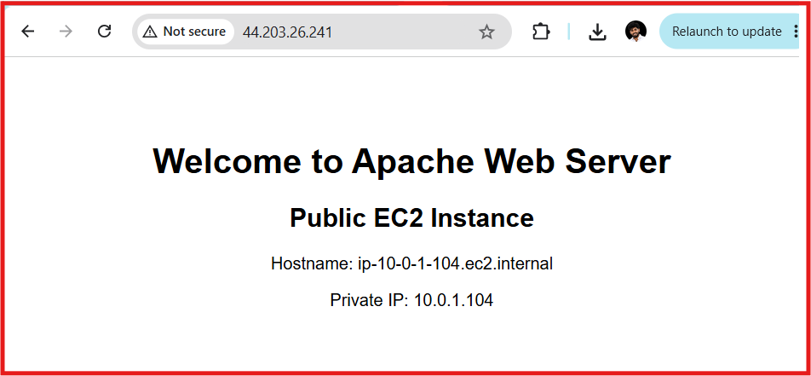
Private EC2
From Public-EC2, test the private server:
curl http://10.0.11.136
Expected output includes:
Welcome to Apache Web Server
Private EC2 Instance
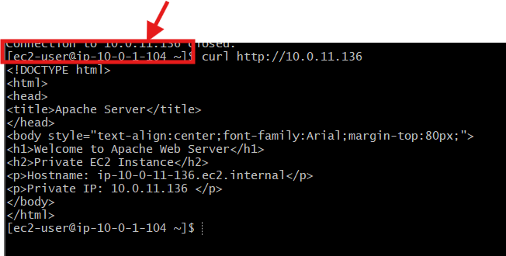

Architecture After Task 7
Internet
│
Internet Gateway
│
Public-Subnet-1
│
Public-EC2 (Apache)
│
SSH / HTTP (Private IP)
│
Private-Subnet-1
│
Private-EC2 (Apache)

Task 8: Create an Application Load Balancer
We will create:
- An ALB security group
- A target group
- Register both EC2 instances
- Create the internet-facing Application Load Balancer
- Test load balancing
The ALB must use at least two subnets in different Availability Zones. It will receive HTTP traffic and forward it to the registered EC2 targets on port 80.

Part A: Create the ALB Security Group
Go to:
EC2
→ Network & Security
→ Security Groups
Click:
Create security group
Enter:
Setting | Value
Security group name | ASG-ALB-SG
Description | Allows internet HTTP traffic to the Application Load Balancer.
VPC | ASG-Lab-VPC
Inbound rule
Add:
Type | Port | Source | Description
HTTP | 80 | 0.0.0.0/0 | Allow public HTTP traffic
Leave the outbound rule as:
All traffic → 0.0.0.0/0
Click:
Create security group
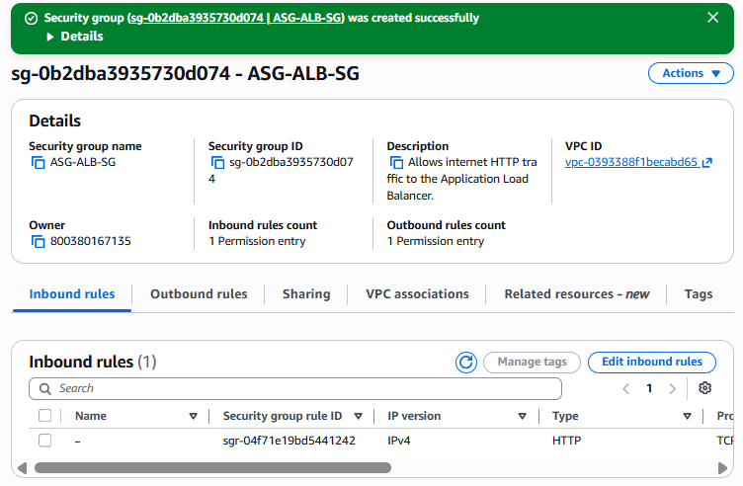
The ALB security group must allow incoming client traffic and outbound communication to its targets on the listener and health-check ports.

Part B: Update the EC2 Security Groups
The load balancer must be able to reach both instances on port 80.
Private-EC2-SG
Go to:
EC2
→ Security Groups
→ Private-EC2-SG
→ Inbound rules
→ Edit inbound rules
Change the HTTP rule from:
HTTP 80 → 10.0.0.0/16
to:
HTTP 80 → ASG-ALB-SG
Description:
Allow HTTP from Application Load Balancer
Keep SSH as:
SSH 22 → Public-EC2-SG
Save the rules.
Public-EC2-SG
Open:
Public-EC2-SG
→ Inbound rules
→ Edit inbound rules
Make sure it contains:
Type | Port | Source
SSH | 22 | My IP
HTTP | 80 | ASG-ALB-SG
If its HTTP rule currently uses 0.0.0.0/0, replace it with ASG-ALB-SG.
This means users access Apache through the ALB rather than directly through the EC2 instance.
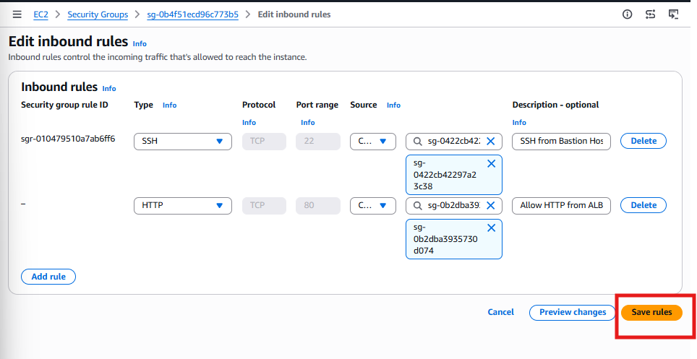

Part C: Create the Target Group
Go to:
EC2
→ Load Balancing
→ Target Groups
Click:
Create target group
Basic configuration
Select:
Instances
Enter:
Setting | Value
Target group name | ASG-Apache-TG
Protocol | HTTP
Port | 80
IP address type | IPv4
VPC | ASG-Lab-VPC
Protocol version | HTTP1
Health checks
Configure:
Setting | Value
Health check protocol | HTTP
Health check path | /
Port | Traffic port
Success codes | 200
You may leave these at their defaults:
Setting | Suggested value
Healthy threshold | 5
Unhealthy threshold | 2
Timeout | 5 seconds
Interval | 30 seconds
The target group performs health checks and the ALB sends traffic only to targets that pass them.
Click:
Next

Part D: Register Both EC2 Instances
Under Available instances, select:
Public-EC2
Private-EC2
Confirm the port is:
80
Click:
Include as pending below
Both instances should appear under Review targets.
Click:
Create target group
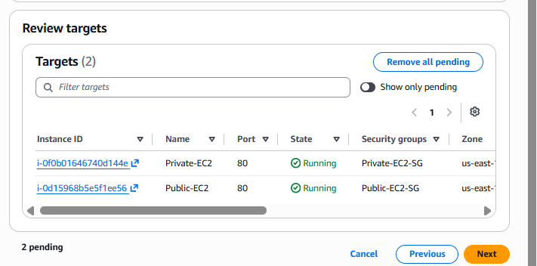

Verify Target Health
Open:
ASG-Apache-TG
→ Targets
Initially, target health might show:
Initial
After health checks complete, both should show:
Healthy
Target registration alone is not enough; each instance must respond successfully to the health-check request before it becomes healthy.

*Because there is no ALB, the Target Group is marked Unused.
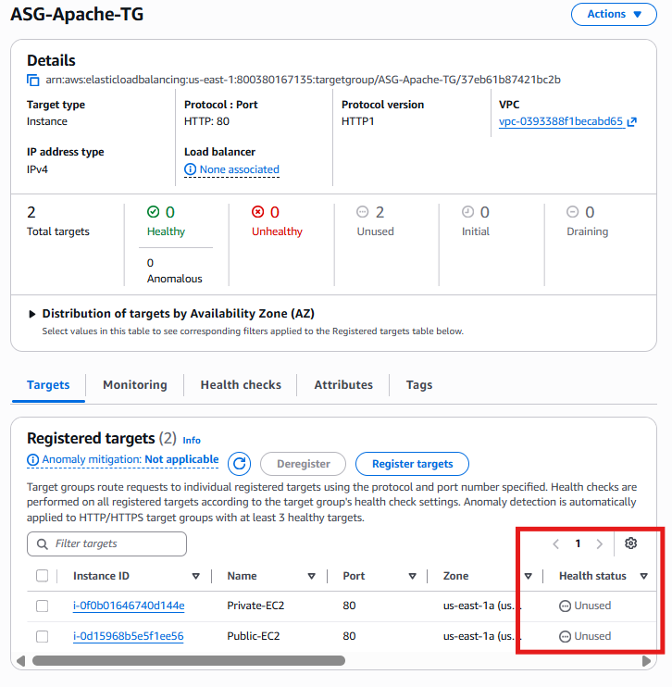

Part E: Create the Application Load Balancer
Go to:
EC2
→ Load Balancers
Click:
Create load balancer
Under Application Load Balancer, click:
Create
Basic configuration
Setting | Value
Load balancer name | ASG-Apache-ALB
Scheme | Internet-facing
Load balancer IP address type | IPv4

Network mapping
Select:
VPC: ASG-Lab-VPC
Under Mappings, select two Availability Zones:
Availability Zone 1
us-east-1a
Subnet: Public-Subnet-1
Availability Zone 2
us-east-1b
Subnet: Public-Subnet-2
Do not select the private subnets for this internet-facing ALB.

Security groups
Remove the default security group if selected.
Choose:
ASG-ALB-SG

Listeners and routing
Configure:
Listener | Default action
HTTP : 80 | Forward to ASG-Apache-TG
We are using HTTP for this lab. In production, HTTPS with an ACM certificate is preferred.
Click:
Create load balancer
Wait until the state becomes:
Active
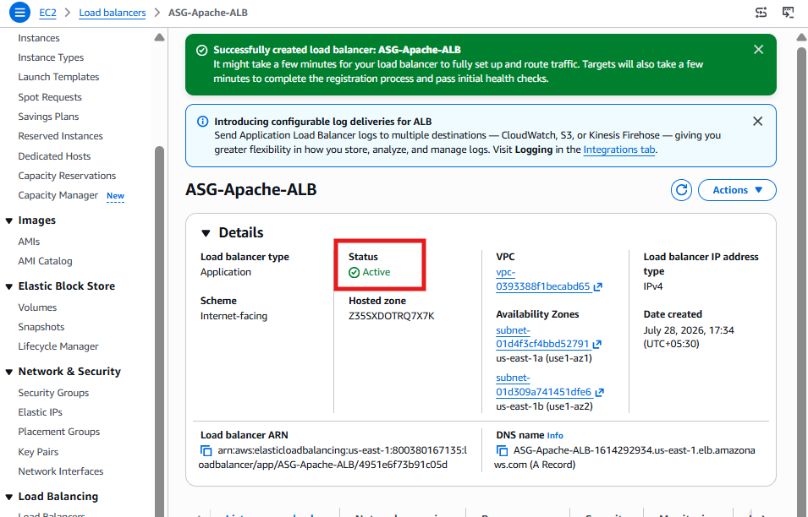

Part F: Test the Application Load Balancer
Select:
ASG-Apache-ALB
Copy its DNS name, for example:
ASG-Apache-ALB-123456789.us-east-1.elb.amazonaws.com
Open it in your browser:
http://ASG-Apache-ALB-1614292934.us-east-1.elb.amazonaws.com
Refresh the browser several times.
You should see either:
Public EC2 Instance
or:
Private EC2 Instance
Because both instances are registered in the target group, the ALB can distribute requests between them.
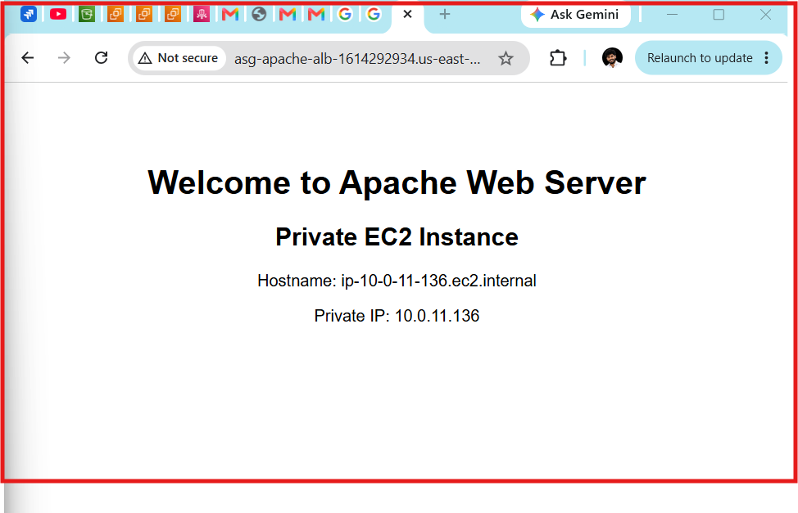

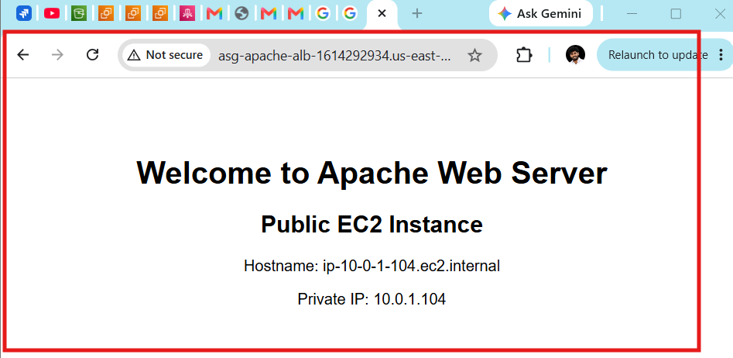

Task 9: Store Application Load Balancer Access Logs in S3
We'll do this in three parts:
- Create an S3 bucket
- Add the bucket policy
- Enable ALB access logging

Step 1: Create an S3 Bucket
Go to:
S3
→ Create bucket
Use the following values:
Setting | Value
Bucket name | asg-apache-alb-logs-800380167135
AWS Region | US East (N. Virginia)
Object Ownership | ACLs disabled (Bucket owner enforced)
Block Public Access | Keep all 4 options enabled ✅
Bucket Versioning | Disabled
Default Encryption | SSE-S3 (Default)
Click:
Create bucket
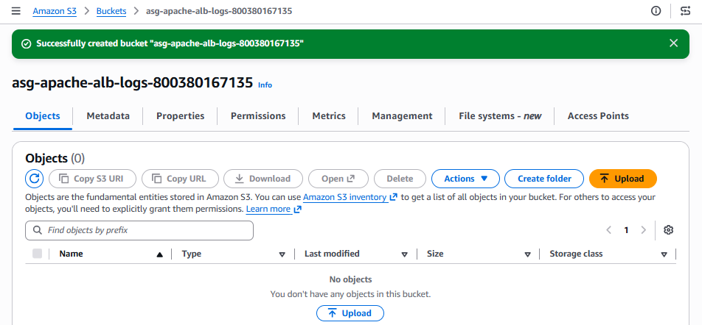

Step 2: Open the Bucket
Open:
asg-apache-alb-logs-800380167135
Go to:
Permissions
Scroll down to:
Bucket Policy
Click:
Edit

Step 3: Add the Bucket Policy
Replace YOUR_ACCOUNT_ID with your AWS Account ID.
For your account (800380167135), use this policy:
{
"Version": "2012-10-17",
"Statement": [
{
"Sid": "AWSLogDeliveryWrite",
"Effect": "Allow",
"Principal": {
"Service": "logdelivery.elasticloadbalancing.amazonaws.com"
},
"Action": "s3:PutObject",
"Resource": "arn:aws:s3:::asg-apache-alb-logs-800380167135/AWSLogs/800380167135/*"
}
]
}
Click:
Save changes
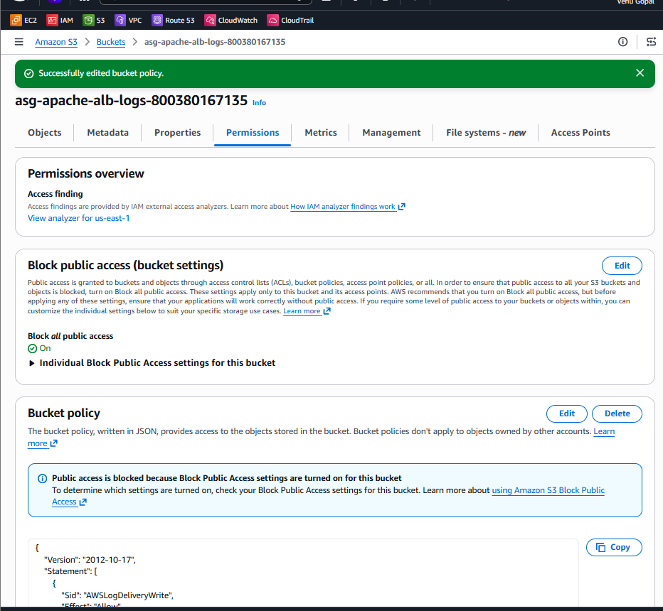

Step 4: Enable Access Logs on the ALB
Go to:
EC2
→ Load Balancers
→ ASG-Apache-ALB
Open the:
Integrations
or
Attributes
tab (AWS may place Access Logs under either, depending on the console version).
Find:
Access Logs
Click:
Edit
Enable:
Enable Access Logs
Configure:
Setting | Value
S3 Bucket | asg-apache-alb-logs-800380167135
Prefix | alb-logs (optional but recommended)
Click:
Save changes
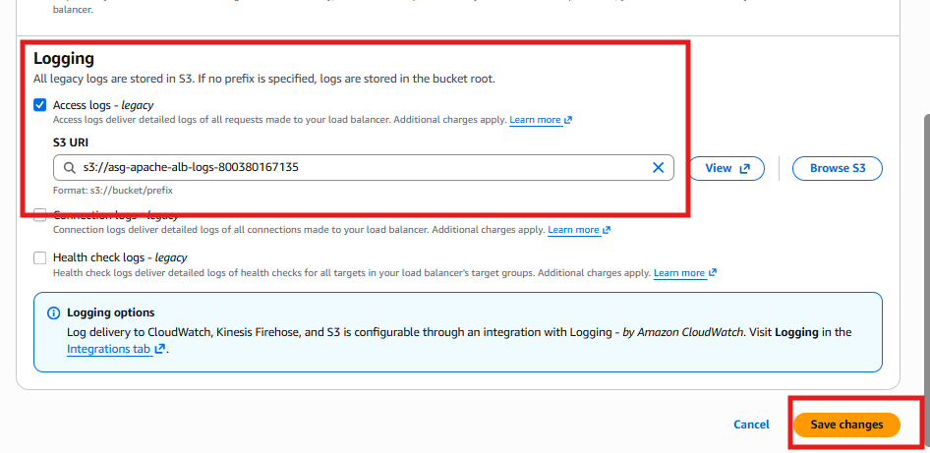

Step 5: Generate Traffic
Open your ALB DNS in the browser and refresh it 20–30 times.
Example:
http://ASG-Apache-ALB-1614292934.us-east-1.elb.amazonaws.com
This generates access log entries.
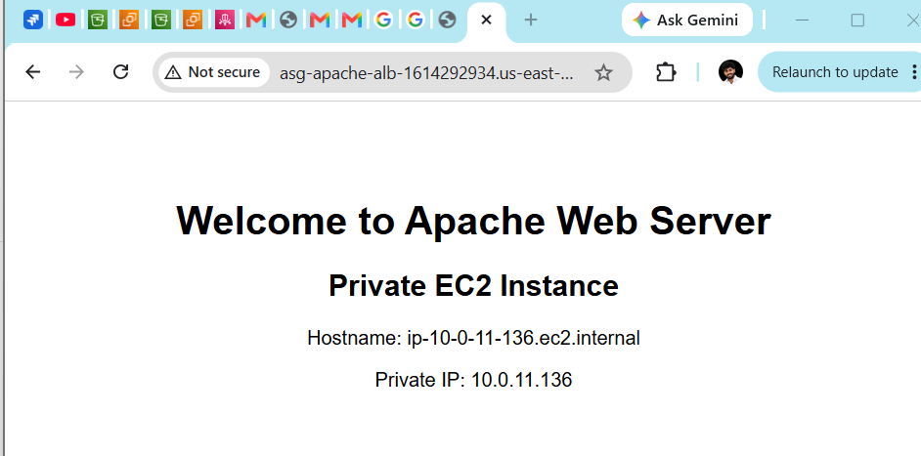

Step 6: Verify Logs
After about 5–10 minutes (ALB access logs are delivered periodically, not instantly):
Go to:
S3
→ asg-apache-alb-logs-800380167135
You should see a folder structure similar to:
alb-logs/
└── AWSLogs/
└── 800380167135/
└── elasticloadbalancing/
└── us-east-1/
└── ...
Inside will be compressed .log.gz files.

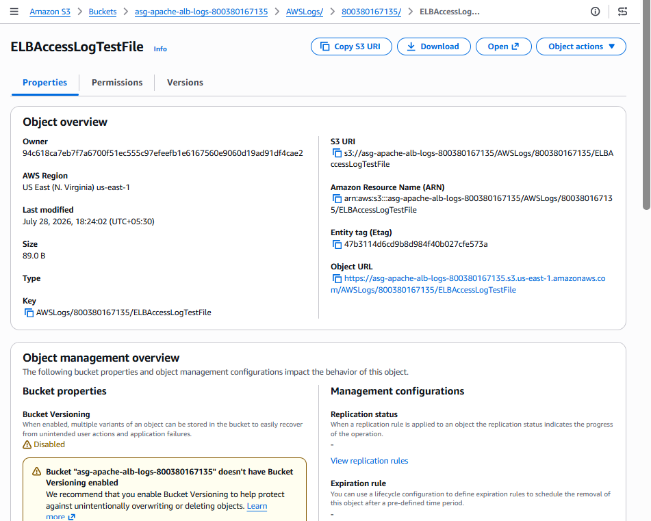

Task 10: Store VPC Flow Logs in a CloudWatch Log Group
Objective
Configure VPC Flow Logs to capture network traffic information for your VPC and send it to Amazon CloudWatch Logs for monitoring and troubleshooting.

Architecture
Internet
│
│
Internet Gateway
│
┌───────────────┐
│ ASG-Lab-VPC │
└───────────────┘
│ │
Public Private
EC2 EC2
│
Network Traffic
│
VPC Flow Logs
│
▼
CloudWatch Log Group
(VPC-FlowLogs)

Prerequisites
Before starting, ensure you have:
- ✅ VPC (ASG-Lab-VPC)
- ✅ Public & Private Subnets
- ✅ Internet Gateway
- ✅ NAT Gateway
- ✅ Route Tables
- ✅ EC2 Instances
- ✅ ALB

Step 1: Create a CloudWatch Log Group
Go to:
AWS Console
→ CloudWatch
→ Logs
→ Log Groups
→ Create log group
Configure
Setting | Value
Log group name | VPC-FlowLogs
Log class | Standard
Retention | Never Expire (or 30 Days)
Click
Create
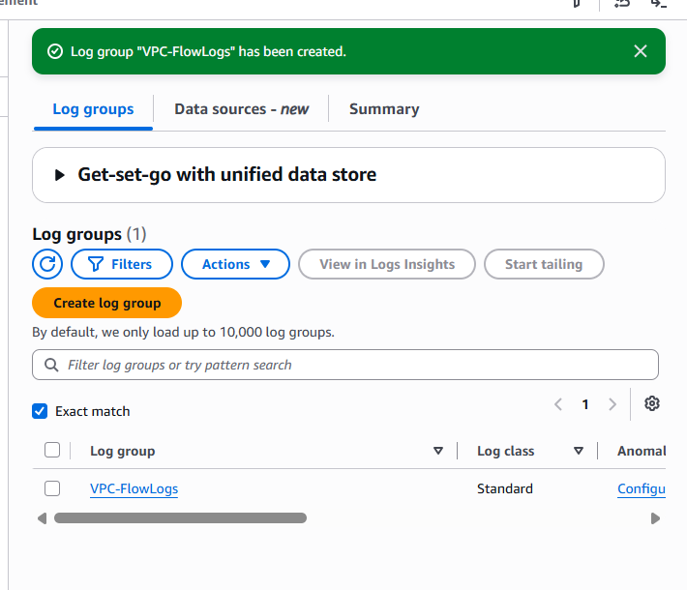

Step 2: Create IAM Role
Go to
IAM
→ Roles
→ Create Role
Trusted Entity
Choose
AWS Service
Service
VPC Flow Logs
Click
Next

Permissions
Attach policy
CloudWatchLogsFullAccess
Click
Next

Role Details
Role Name
VPCFlowLogsRole
Description
Allows VPC Flow Logs to publish logs to CloudWatch.
Click
Create Role
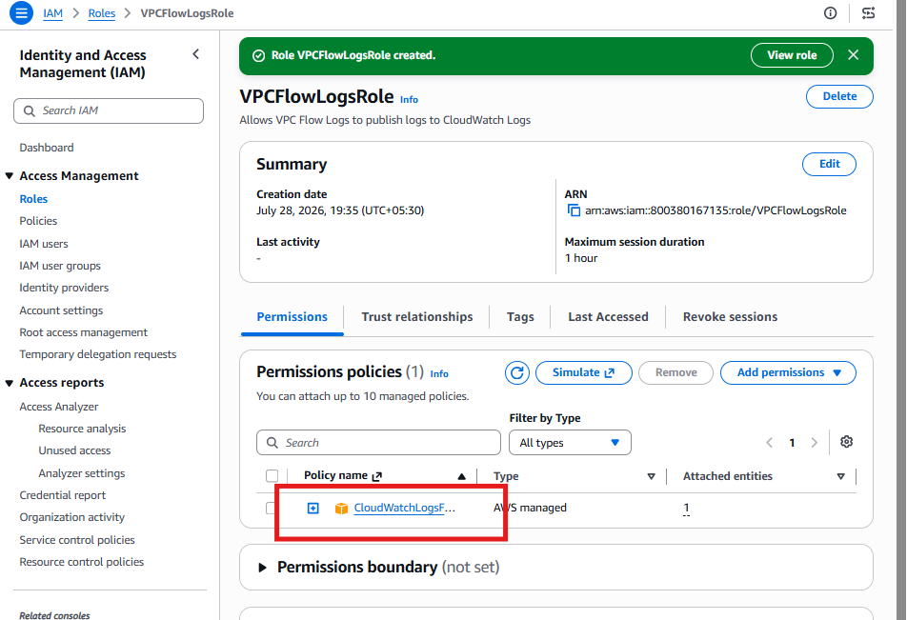

Step 3: Create VPC Flow Log
Go to
VPC Console
→ Your VPCs
Select
ASG-Lab-VPC
Open
Flow Logs
Click
Create Flow Log
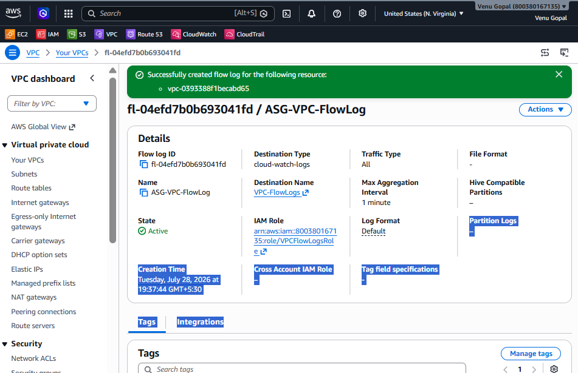

Step 4: Configure Flow Log
Name
ASG-VPC-FlowLog

Filter
Choose
All
Captures
- Accepted Traffic
- Rejected Traffic

Maximum Aggregation Interval
Choose
1 Minute

Destination
Choose
Send to CloudWatch Logs

Destination Log Group
Select
VPC-FlowLogs

IAM Role
Select
VPCFlowLogsRole

Log Record Format
Choose
Default AWS Format

Tags
Optional
Key | Value
Name | ASG-VPC-FlowLog

Click
Create Flow Log

Step 5: Verify Flow Log
Go to
VPC
→ Your VPC
→ Flow Logs
Expected
Status : Active
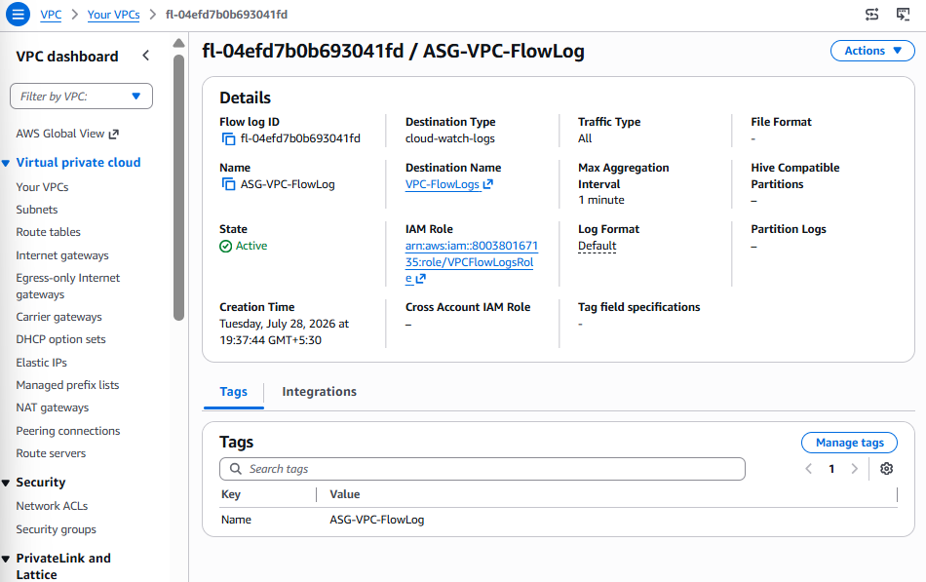

Step 6: Generate Network Traffic
Open browser
http://<ALB-DNS-Name>
Refresh
15–20 times
OR
SSH into Public EC2
curl http://<Private-IP>
Run
ping <Private-IP>
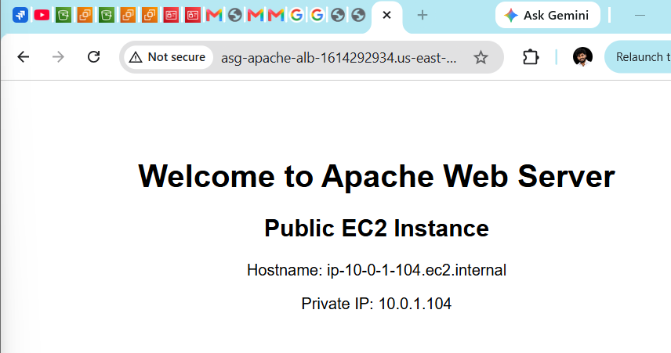
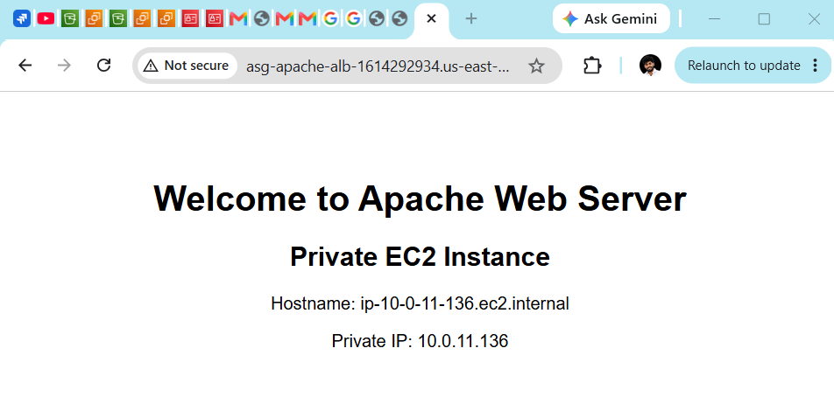

Step 7: Verify CloudWatch Logs
Go to
CloudWatch
→ Logs
→ Log Groups
Open
VPC-FlowLogs
You should see
eni-xxxxxxxxxxxx
Open one stream.
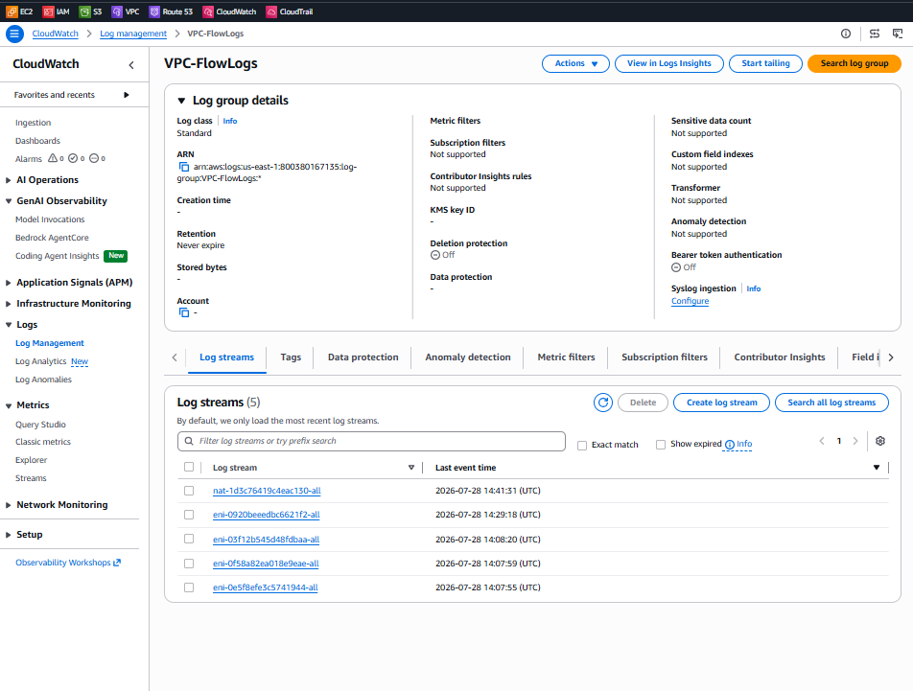

Expected Log
2
123456789012
eni-08ab1234567890
10.0.1.15
10.0.11.25
53210
80
6
15
1256
1722343200
1722343260
ACCEPT
OK

Understanding Each Field
Field | Meaning
Version | Flow Log version
Account ID | AWS Account
ENI | Elastic Network Interface
Source IP | Client IP
Destination IP | Target IP
Source Port | Source port
Destination Port | Destination port
Protocol | 6 = TCP
Packets | Number of packets
Bytes | Data transferred
Start Time | Session start
End Time | Session end
Action | ACCEPT / REJECT
Status | OK

Testing
Generate these activities:
- Access ALB
- SSH Public EC2
- SSH Public → Private EC2
- Ping Private EC2
- HTTP request to Apache
Then verify logs appear in CloudWatch.

Expected Output
Flow Log Status : Active

Destination : CloudWatch Logs

Log Group : VPC-FlowLogs

Traffic : ACCEPT

Protocol : TCP

Port : 80

Source : Public EC2

Destination : Private EC2

Project Deliverable
Successfully configured VPC Flow Logs to capture all network traffic within the ASG-Lab-VPC and publish it to the CloudWatch Log Group (VPC-FlowLogs), enabling centralized monitoring, troubleshooting, and network traffic analysis.

Task 11: Create CloudWatch Dashboard for CPU Utilization and Apache Monitoring.
We'll do this one step at a time.

Task 11 – Step 1: Open CloudWatch Dashboards
Go to:
AWS Console
→ CloudWatch
→ Dashboards
Click:
Create dashboard

Step 2: Enter Dashboard Name
Use the following name:
ASG-Monitoring-Dashboard
Click:
Create dashboard

Step 3
Leave these selections as they are:
- ✅ Data type: Metrics
- ✅ Widget type: Line
Now click:
Next

Step 4
On the next page, navigate to:
Browse
→ EC2
→ Per-Instance Metrics
Then select the metric:
CPUUtilization
for your instance(s). You should see instances like:
- Public-EC2
- Private-EC2
Select both if you want to monitor both instances.
Step5:
Select the Metric
Navigate to:
Browse
→ EC2
→ Per-Instance Metrics
Select:
NetworkIn
for your EC2 instance.
Then click:
Create widget

Step 6: Save the Dashboard
Click:
Save dashboard

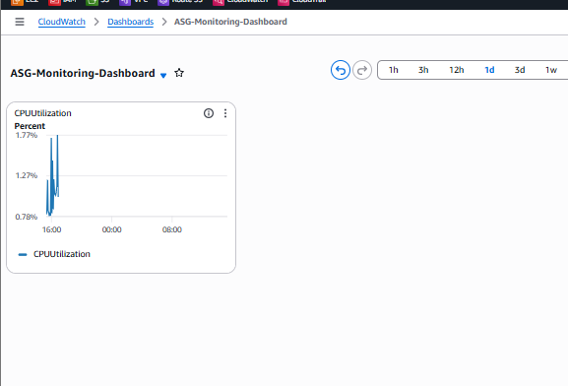
Step 7:Add the NetworkOut Widget
- On your dashboard, click:
+ Add widget
- Select:
  - ✅ Metrics
  - ✅ Line
- Click Next

Step 8: Select the Metric
Navigate to:
Browse
→ EC2
→ Per-Instance Metrics
Select:
NetworkOut
for the same EC2 instance that you used for the CPU widget.
Click:
Create widget
Then click:
Save dashboard
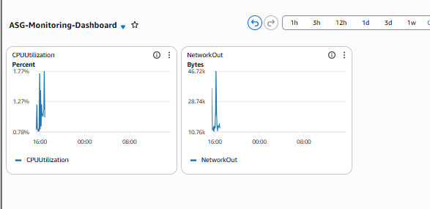

Next Step
- Select EBSReadBytes for either:
  - Public-EC2, or
  - Private-EC2 (depending on which instance you're monitoring)
- Click Create widget.
- Repeat the process for EBSWriteBytes.
- Finally, add:
  - StatusCheckFailed (not StatusCheckFailed_System or StatusCheckFailed_Instance; use the overall StatusCheckFailed metric).

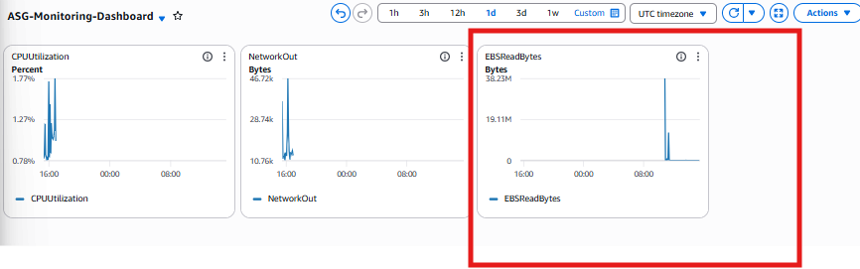
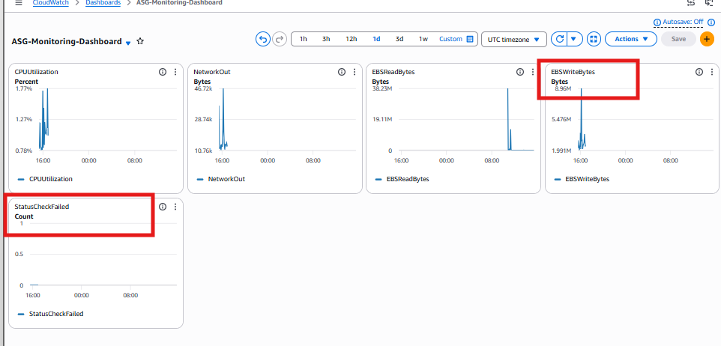

Task 12: Configure Auto Scaling when CPU > 70%
Objective
Automatically launch a new EC2 instance when average CPU utilization exceeds 70%, and terminate it when CPU utilization drops.

Architecture
Internet
│
▼
Application Load Balancer
│
┌─────────────┴─────────────┐
│ │
EC2 Instance 1 EC2 Instance 2
(Apache) (Apache)
▲ ▲
└────────── Auto Scaling Group ──────────┘
│
Launch Template
│
CPU Alarm > 70%
│
Scale Out (+1 Instance)

CPU < 30%
│
▼
Scale In (-1 Instance)

Step 1: Create a Launch Template
Go to:
EC2
→ Launch Templates
→ Create launch template
Fill the details:
Field | Value
Launch template name | ASG-Apache-LT
Version description | Version 1
AMI | Amazon Linux 2023 (same AMI used earlier)
Instance Type | t3.micro
Key Pair | Your existing key
Security Group | Private-EC2-SG (or the SG used by your Apache instance)
IAM Role | None (unless required)
Storage | Default
User Data | Apache installation script
User Data:
#!/bin/bash
dnf update -y
dnf install -y httpd
systemctl enable httpd
systemctl start httpd
echo "<h1>Apache from Auto Scaling Instance</h1>" > /var/www/html/index.html
Click
Create Launch Template
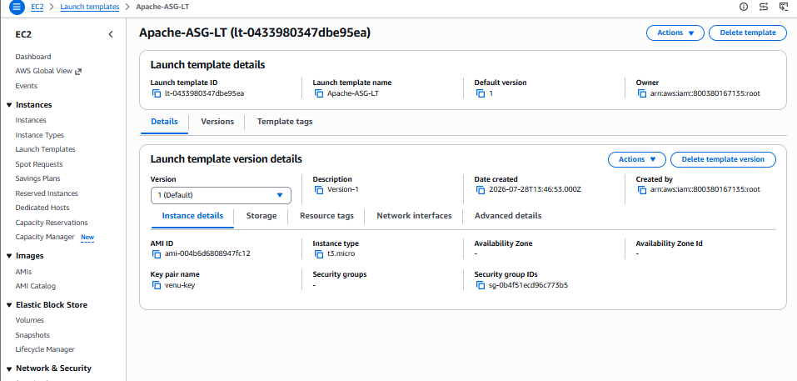

Step 2: Create Auto Scaling Group
Go to
EC2
→ Auto Scaling Groups
→ Create Auto Scaling Group
Fill
Field | Value
Name | Apache-ASG
Launch Template | ASG-Apache-LT
Click
Next

Step 3: Network
Select
VPC
Choose
ASG-Lab-VPC
Select Subnets
Private-Subnet-1
Private-Subnet-2
Click
Next
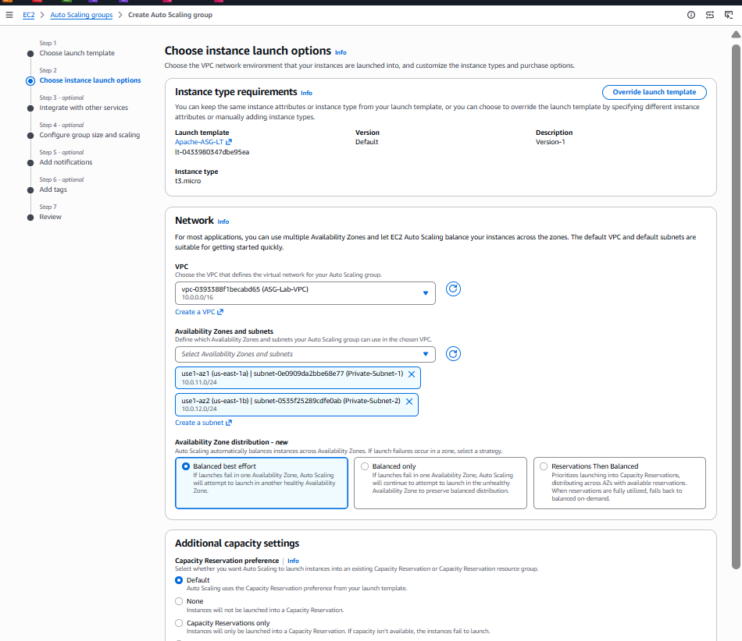

Step 4: Attach Load Balancer
Choose
Attach to existing Load Balancer
Select
ASG-Apache-ALB
Target Group
ASG-Apache-TG
Health Check
ELB
Turn ON
Health Checks
Click
Next

Step 5: Group Size
Desired Capacity
1
Minimum
1
Maximum
3
Click
Next
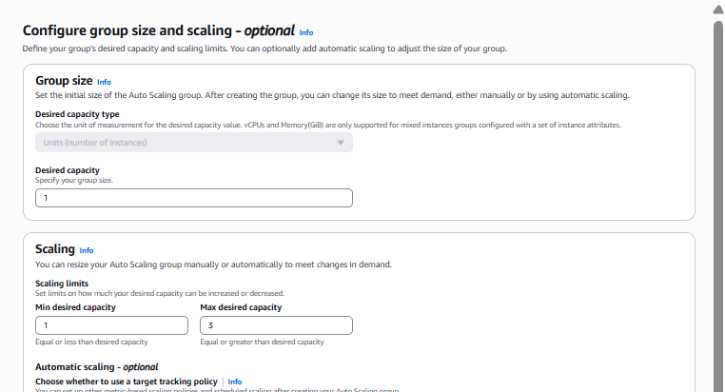

Step 6: Scaling Policy
Choose
Target Tracking Scaling Policy
Metric
Average CPU Utilization
Target Value
70%
Warm-up
300 Seconds
Click
Next

Step 7: Notifications
Skip
Next

Step 8: Tags
Add
Key | Value
Name | Apache-ASG-Instance
Click
Next

Step 9: Review
Verify
Launch Template
Network
Target Group
Scaling Policy
Click
Create Auto Scaling Group
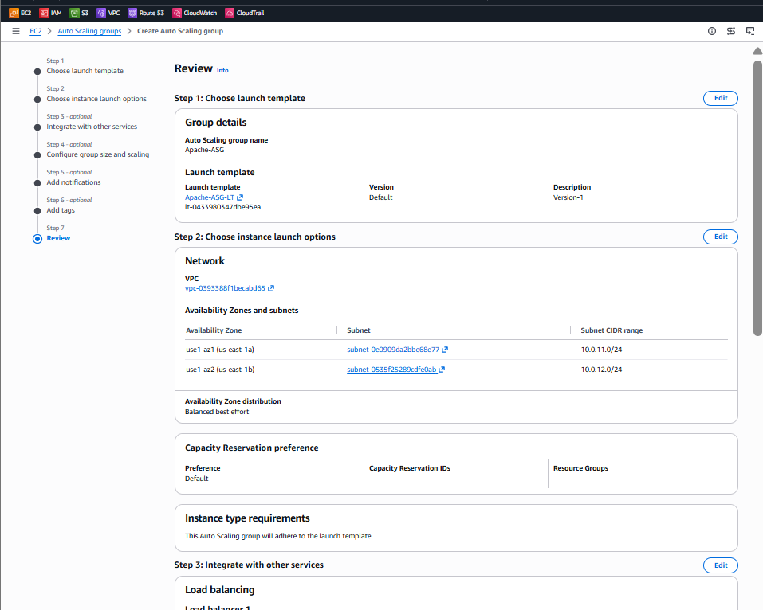
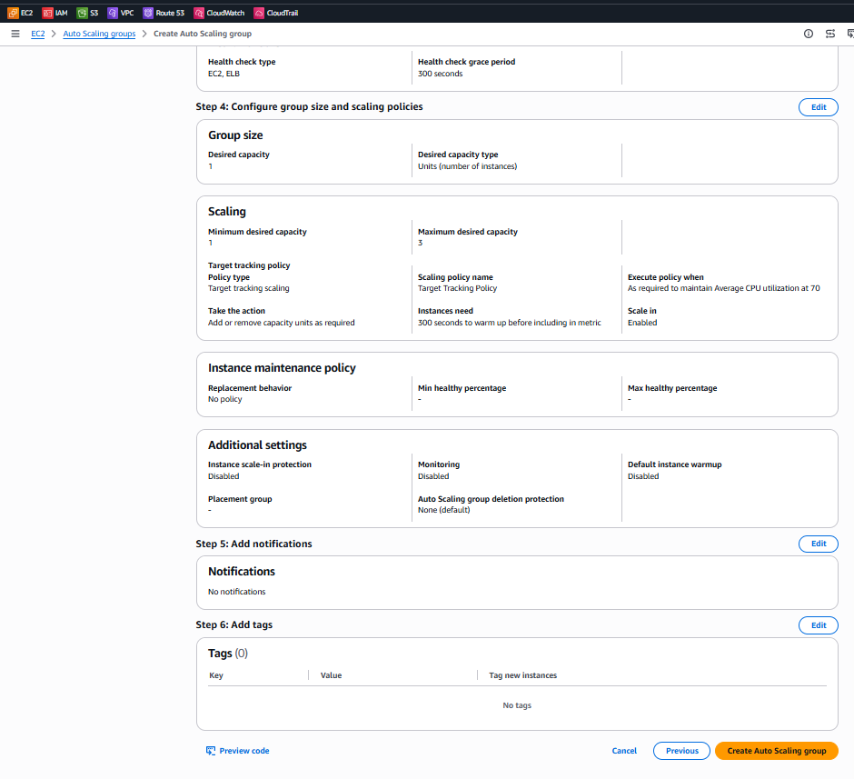

Step 10: Verify
Go to
EC2
Initially you should see
1 Instance
Running.
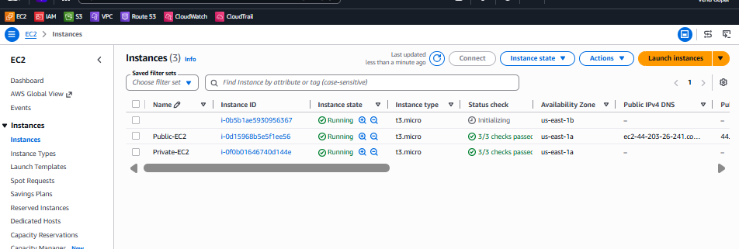

Step 11: Generate CPU Load
SSH into the EC2 instance
Install stress tool
Amazon Linux 2023
sudo dnf install -y stress
Run
stress --cpu 2 --timeout 600
or
yes > /dev/null &
yes > /dev/null &
Verify
top
CPU should approach
70-100%

Step 12: Verify Scaling
Go to
EC2
→ Auto Scaling Groups
→ Apache-ASG
→ Activity
You should see
Launching a new EC2 instance
Go to
EC2
→ Instances
Now
2 Running Instances
should appear.
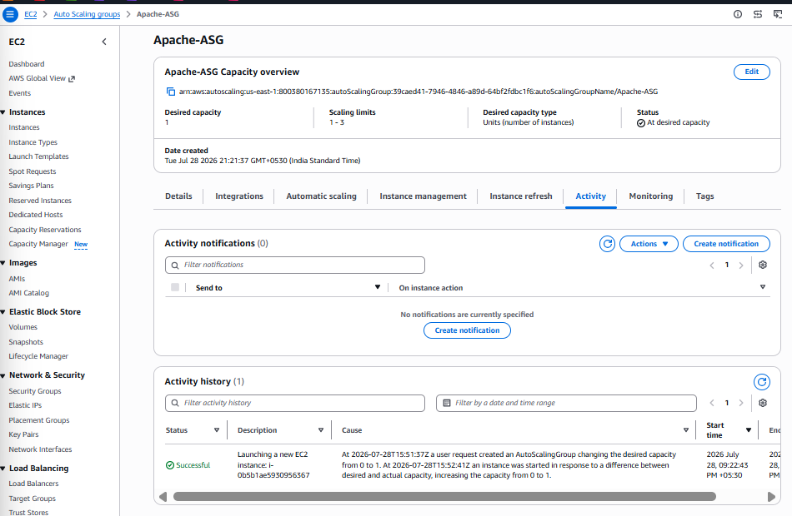

Step 13: Verify Load Balancer
Open
EC2
→ Target Groups
→ Targets
Both instances should show
Healthy
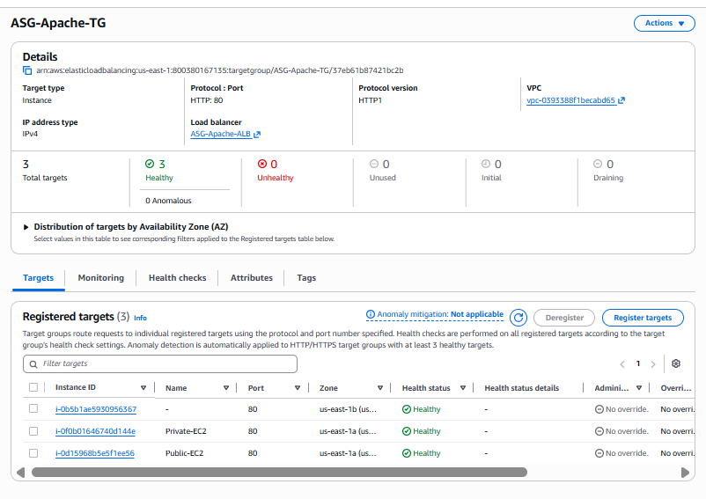

Step 14: Stop CPU Stress
pkill stress
or
killall yes
Wait 10–15 minutes.

Step 15: Verify Scale-In
Auto Scaling Activity should show
Terminating EC2 instance
The instance count returns to
1 Running Instance
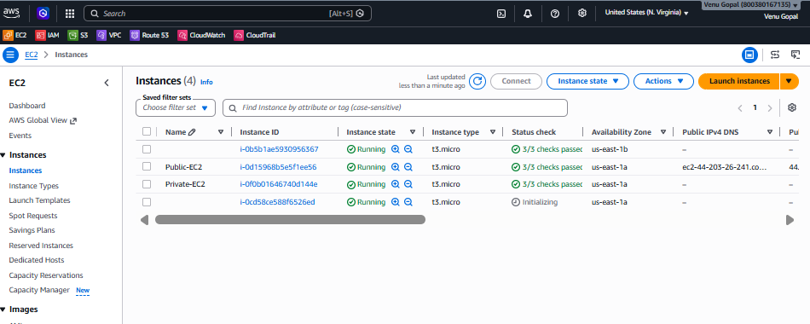
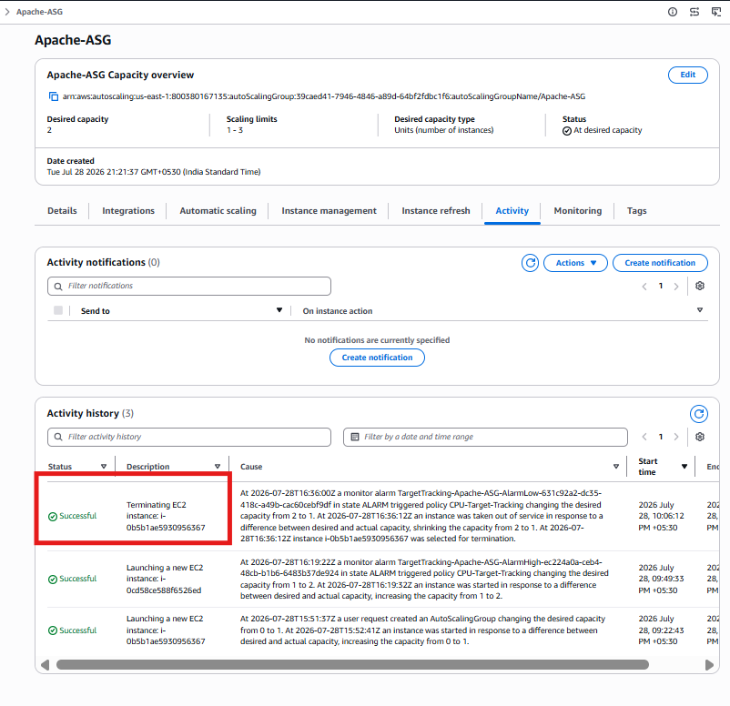
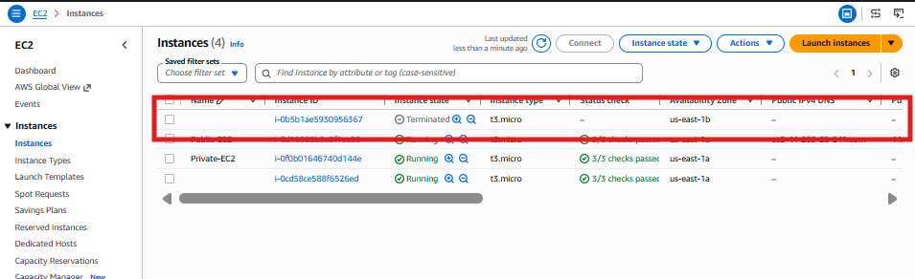
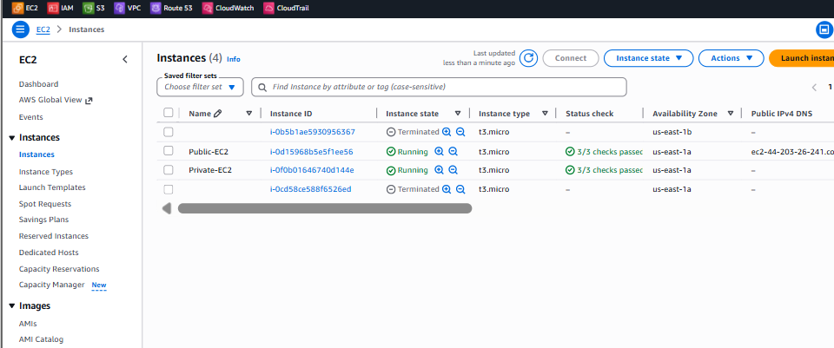
- Final Architecture
Internet
│
▼
Application Load Balancer
│
┌──────────────┴──────────────┐
│ │
Apache EC2 Apache EC2
▲ ▲
└──────── Auto Scaling Group ────────┘
│
Launch Template
│
CPU >70% → Scale Out (+1)

CPU <30% → Scale In (-1)

